**EXPERIMENT 8:** *Performing CRUD Operations on Apache Hive*

**Name: Adwait Purao**

**UID : 2021300101**

**Division: COMPS B**

1. **Create Table cricket_matches**
   1. **Query** :

| **CREATE** **TABLE** cricket_matches (  match_id INT,  team1 **STRING**,  team2 **STRING**,  match_date DATE,  venue **STRING**,  **result** **STRING** ); |
| --- |

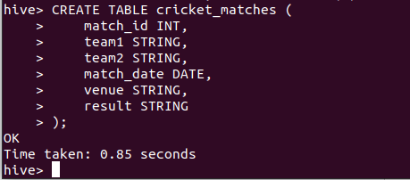

1. **Insert into table cricket_matches**
   1. **Query** :

| ***INSERT******INTO*** *cricket_matches* ***VALUES*** *(1, 'India', 'Australia', '2024-03-25', 'Melbourne Cricket Ground', 'India won by 50 runs'), (2, 'England', 'New Zealand', '2024-03-26', 'Lord''s Cricket Ground', 'New Zealand won by 3 wickets'), (3, 'South Africa', 'Pakistan', '2024-03-27', 'Wanderers Stadium', 'Match tied');* |
| --- |

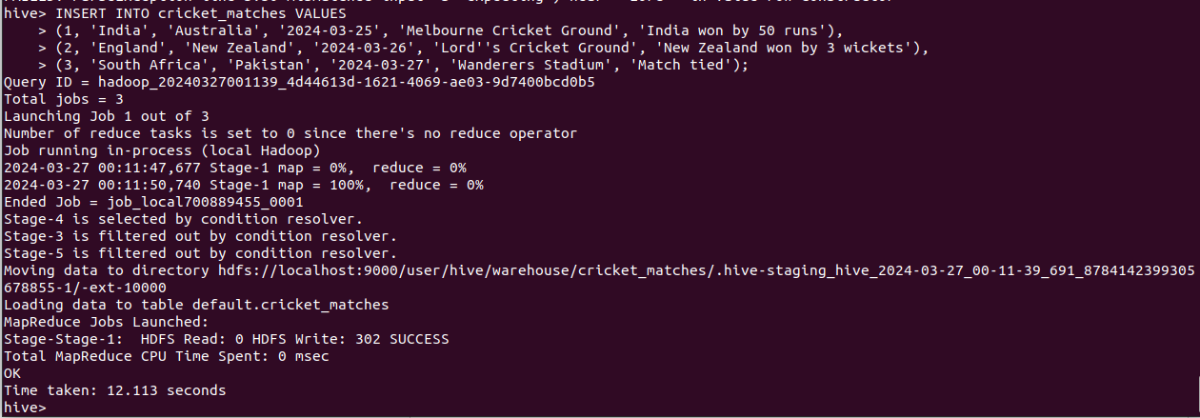

**3) Select Data from table cricket_matches**

* 1. **Query** :

| ***SELECT*** *\** ***FROM*** *cricket_matches;* |
| --- |

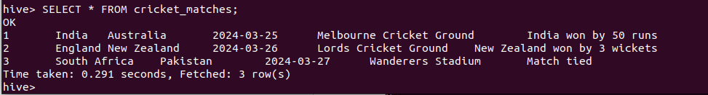

**4) Alter Table cricket_matches**

* 1. **Query** :

| ***ALTER******TABLE*** *cricket_matches* ***ADD******COLUMNS*** *(winning_team* ***STRING****);* |
| --- |

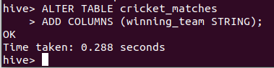

**5) Update Table cricket_matches**

* 1. **Query** :

| ***INSERT*** *OVERWRITE* ***TABLE*** *cricket_matches* ***SELECT*** *match_id, team1, team2, match_date, venue,* ***result****,* ***CASE******WHEN******result******LIKE*** *'%India%'* ***THEN*** *'India'* ***WHEN******result******LIKE*** *'%New Zealand%'* ***THEN*** *'New Zealand'* ***WHEN******result******LIKE*** *'%South Africa%'* ***THEN*** *'South Africa'* ***ELSE*** *'Unknown'* ***END******AS*** *winning_team* ***FROM*** *cricket_matches;* |
| --- |

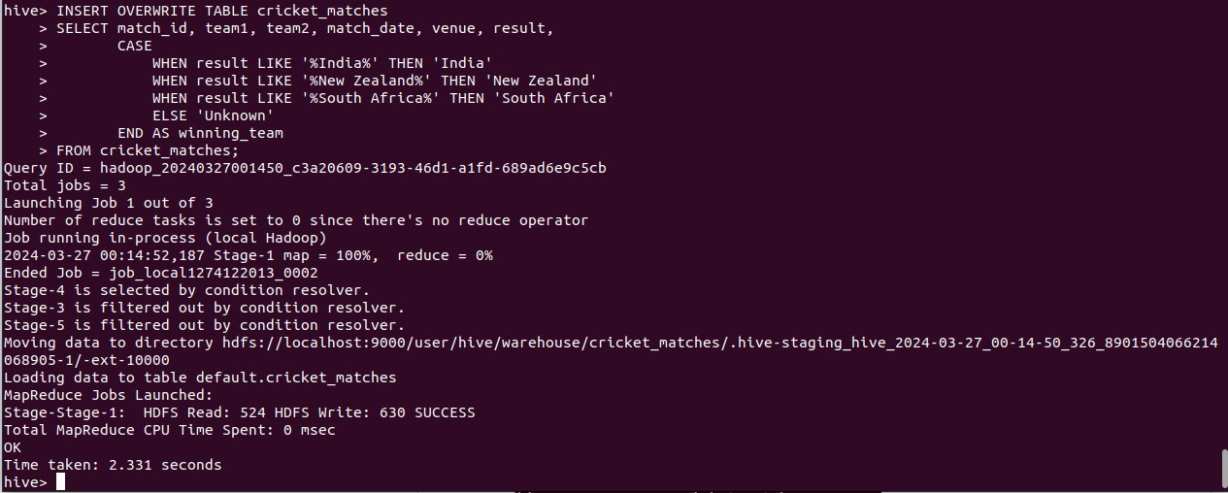

**6) Delete Data from table cricket_matches**

* 1. **Query** :

| ***CREATE******TABLE*** *cricket_matches_new* ***AS******SELECT*** *\** ***FROM*** *cricket_matches* ***WHERE*** *match_id <> 1;* ***DROP******TABLE*** *cricket_matches;* ***ALTER******TABLE*** *cricket_matches_new* ***RENAME******TO*** *cricket_matches;* |
| --- |

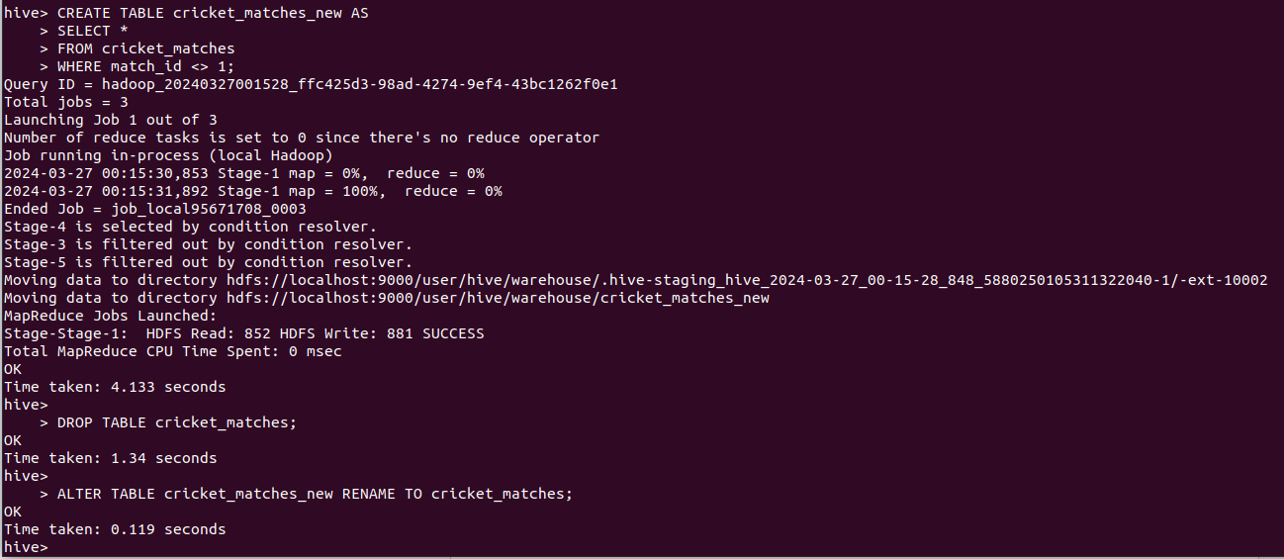

**7) Show all tables in Database**

* 1. **Query** :

| **show** **tables**; |
| --- |

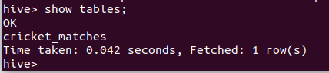

**8) Load Data from CSV file**

cricket_players.csv :

| 1,Player1,India 2,Player2,Australia 3,Player3,England |
| --- |

1. **Query** :
   1. First Create Table

| **CREATE** **TABLE** cricket_players (  player_id INT,  player_name **STRING**,  country **STRING** ); |
| --- |

* 1. Then copy the csv file to hadoop file system

| hadoop fs -put /path/to/players.csv /user/hive/warehouse/cricket_players/ |
| --- |

* 1. Load Data into hive table

| **LOAD** **DATA** INPATH '/user/hive/warehouse/cricket_players/players.csv' **INTO** **TABLE** cricket_players; |
| --- |

